## VISVESVARAYA TECHNOLOGICAL UNIVERSITY

**BELGAVI, KARNATAKA -590 018**

**A Mini-Project Report on**

## “WEATHER APP”

***Submitted in partial fulfillment for the Full stack development (21CS62) course of Sixth Semester of Bachelor of Engineering in Computer Science & Engineering during the academic year 2023-24.***

**By**

|  |  |
| --- | --- |
| **GAUTAM PRABHU H M 4MH21CS027** | |
| **HARSHA S** | **4MH21CS032** |

**SUnder the Guidance of :**

**Prof. Ranjith K C**

**Assistant Professor Department of CS&E MIT Mysore**

#### DEPARTMENT OF COMPUTER SCIENCE & ENGINEERING

**MAHARAJA INSTITUTE OF TECHNOLOGY MYSORE**

**Belawadi, S.R. Patna Taluk, Mandya Dist-571477.**

|  |  |  |
| --- | --- | --- |
| **Accredited By:** | National Board of Accreditation - Wikipedia |  |

**2023-24**

#### DEPARTMENT OF COMPUTER SCIENCE & ENGINEERING

MAHARAJA INSTITUTE OF TECHNOLOGY MYSORE

 **CERTIFICATE **

*Certified that the mini-project work entitled “****WEATHER FORECAST*”**

*is a bonafide work carried out by* ***Gautam Prabhu H M (4MH21CS027)*** *&* ***Harsha S (4MH21CS032)*** *for the Full stack development (21CS62) of Sixth Semester in Computer Science & Engineering under Visvesvaraya Technological University, Belgavi during academic year 2023-24.*

*It is certified that all corrections/suggestions indicated for Internal Assignment have been incorporated in the report. The report has been approved as it satisfies the course requirements.*

|  |  |
| --- | --- |
| _ _ _ _ _ _ _ _ _ _ _ _ _ _ _ _ _ Signature of Guide  **Prof. Ranjith K C**  Assistant Professor Dept. of CS&E  MIT Mysore | _ _ _ _ _ _ _ _ _ _ _ _ _ _ _ _ _ Signature of the HOD  **Dr. Shivamurthy R C**  Professor & HOD Dept. of CS&E MIT Mysore |

**External viva**

**Name of the Examiners Signature with date**

1)………………………………………………………………………………

2) ………………………………………………………………………………

# INTRODUCTION

## Definition

Weather forecasting is the application of science and technology to predict the conditions of the atmosphere for a given location and time. This involves the use of various methods and tools to forecast parameters like temperature, precipitation, wind, and humidity.

## Importance

Weather forecasting plays a crucial role in various aspects of human life and the economy:

* **Agriculture**: Farmers rely on accurate weather forecasts to plan planting, irrigation, and harvesting. Weather information helps in protecting crops from adverse weather conditions.
* **Transportation**: Airlines, shipping companies, and road transport services use weather forecasts to ensure safety and efficiency. Weather conditions can significantly impact travel plans and logistics.
* **Emergency Management**: Accurate weather predictions are essential for preparing for and responding to natural disasters such as hurricanes, floods, and severe storms. Early warnings can save lives and reduce economic losses.
* **Daily Life**: Individuals use weather forecasts to make informed decisions about clothing, travel, and outdoor activities, ensuring comfort and safety.
* **Energy Management**: Forecasting weather conditions is vital for energy providers to manage demand and supply, especially for renewable energy sources like solar and wind power.

### History of Weather Forecasting

#### Early Methods

* **Ancient Civilizations**: Early methods of weather prediction were based on observing the sky, animal behavior, and other natural phenomena. For instance, the Greeks developed theories about weather patterns and used rudimentary instruments like the wind vane.
* **Folklore and Proverbs**: Many traditional sayings and proverbs were based on long-term observations of weather patterns. For example, "Red sky at night, sailor's delight; red sky in the morning, sailors take warning" reflects weather patterns observed over centuries.

#### Scientific Advancements

* **17th Century**: The invention of the barometer by Evangelista Torricelli allowed for the measurement of atmospheric pressure, leading to better weather predictions.
* **19th Century**: The development of the telegraph enabled the rapid exchange of weather observations, facilitating the creation of the first weather maps and forecasts.
* **20th Century**: The advent of computers and the development of numerical weather prediction models marked a significant leap in forecasting accuracy. Satellite technology provided a global view of weather systems, enhancing the ability to monitor and predict weather conditions.

### Modern Weather Forecasting

#### Data Collection

* **Surface Observations**: Weather stations worldwide measure temperature, humidity, wind speed, direction, and atmospheric pressure, providing essential data for forecasting models.
* **Upper-Air Observations**: Weather balloons equipped with radiosondes collect data on temperature, humidity, and pressure at various altitudes, crucial for understanding the vertical structure of the atmosphere.
* **Satellite Observations**: Weather satellites monitor atmospheric conditions, cloud cover, and sea surface temperatures, offering comprehensive coverage of weather systems.
* **Radar**: Doppler radar systems detect precipitation, its intensity, and movement, aiding in short-term weather forecasts and severe weather warnings.

## Forecasting Models

* **Numerical Weather Prediction (NWP)**: Uses mathematical models to simulate the atmosphere and predict future weather conditions based on current observations.
* **Statistical Models**: Analyze historical weather data to identify patterns and predict future conditions.
* **Ensemble Forecasting**: Involves running multiple models or variations of a model to account for uncertainties, providing a range of possible outcomes.

## Forecasting Process

1. **Data Assimilation**: Collecting and integrating data from various sources to create a comprehensive snapshot of current atmospheric conditions.
2. **Model Initialization**: Starting the forecasting models with the current atmospheric conditions.
3. **Model Execution**: Running simulations to predict future weather conditions.
4. **Post-Processing**: Refining model outputs using statistical techniques and expert judgment to improve accuracy.
5. **Dissemination**: Communicating forecasts to the public through various media channels, including television, radio, internet, and mobile apps.

### Challenges in Weather Forecasting

* **Atmospheric Complexity**: The atmosphere is a dynamic and chaotic system, making precise predictions challenging.
* **Model Limitations**: Imperfections in models and incomplete data can affect forecast accuracy.
* **Scale of Prediction**: Forecasting small-scale events like thunderstorms is more challenging than predicting large-scale systems like hurricanes.

### Future of Weather Forecasting

* **Improved Models**: Advances in computational power and modeling techniques will enhance forecast accuracy.
* **Enhanced Observations**: New technologies, such as improved satellites and more extensive sensor networks, will provide better data.
* **Artificial Intelligence**: AI and machine learning will play a larger role in analyzing data and making predictions, potentially improving the accuracy and timeliness of weather forecasts.

## CODE : -

**Manage.py**

#!/usr/bin/env python

"""Django's command-line utility for administrative tasks.""" import os

import sys def main():

"""Run administrative tasks.""" os.environ.setdefault('DJANGO_SETTINGS_MODULE', 'weatherapp.settings') try:

from django.core.management import execute_from_command_line except ImportError as exc:

raise ImportError(

"Couldn't import Django. Are you sure it's installed and " "available on your PYTHONPATH environment variable? Did you " "forget to activate a virtual environment?"

) from exc execute_from_command_line(sys.argv)

if name == ' main ': main()

## url.py

from django.contrib import admin from django.urls import path, include urlpatterns = [

path('admin/', admin.site.urls),

path('', include('weather.urls')), # Root URL includes weather app's URLs

]

View.py

from django.shortcuts import render import requests

def weather_view(request):

api_key = '9bea4413a3c8cd354b91aa1e9998b60a' weather_data = None

if request.method == 'POST':

country = request.POST.get('country')

url =

f'[http://api.openweathermap.org/data/2.5/weather?q={](http://api.openweathermap.org/data/2.5/weather?q)country}&appid={api_key} &units=metric'

response = requests.get(url) data = response.json()

if response.status_code == 200: weather_data = {

'location': data['name'], 'temperature': data['main']['temp'],

'condition': data['weather'][0]['description'],

'humidity': data['main']['humidity'],

'wind_speed': data['wind']['speed']

}

else:

weather_data = { 'location': 'N/A', 'temperature': 'N/A', 'condition': 'N/A',

'humidity': 'N/A', 'wind_speed': 'N/A'

}

return render(request, 'weather.html', {'weather_data': weather_data})

# Screenshots : -

# Step 1:Place Specifying Phase

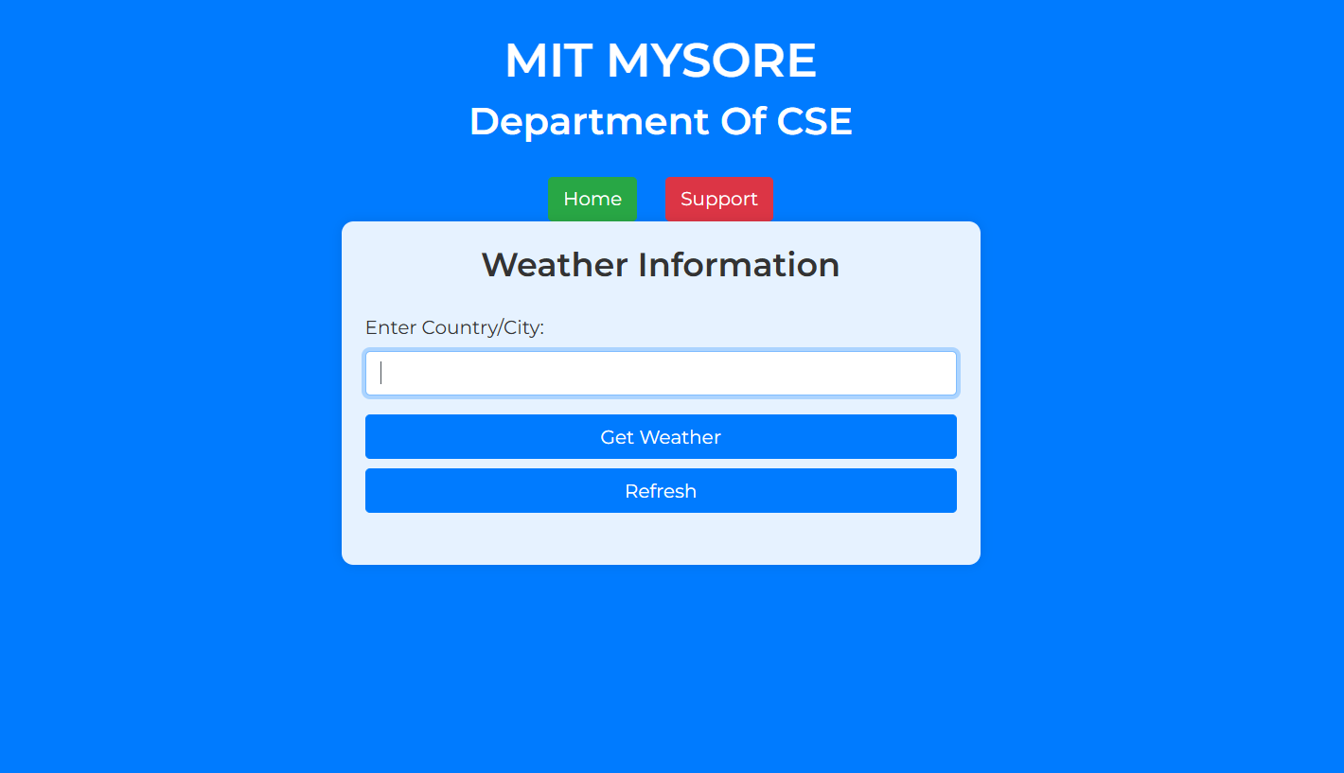

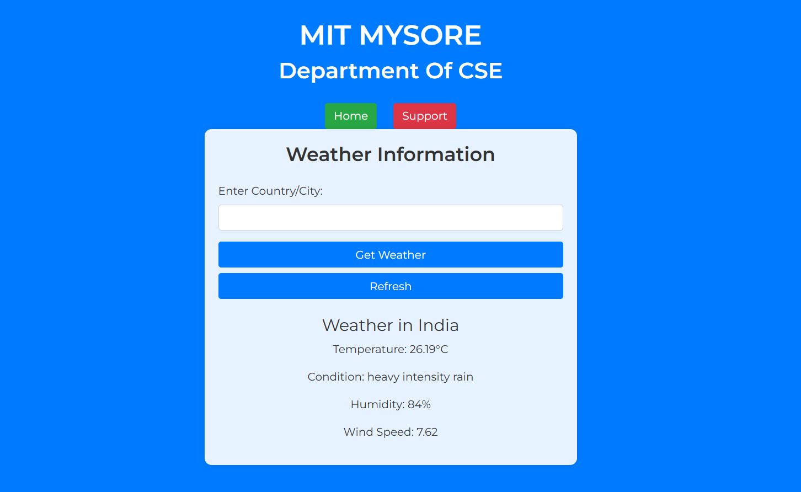**Step 2:Fetching Whether Data**

**Step 3:Support Team**

